Assignment Module: 17

- Full form of “ ping “
Answer: Packet Internet Groper.

- What is the use of “ping “command ?
Answer: Used to check connectivity between two network devices and measure response time (latency).

- What is the meaning of “prefix” is?
Answer: In IP addressing, prefix represents the subnet mask length (e.g., /24) that defines the network.

- Which protocol is used in PING?
Answer: Internet Control Message Protocol (ICMP).

- Port number of ICMP?
Answer: ICMP does not use port numbers because it works at the network layer.

- What is network ID and broadcast ID in IP range?
Answer: Network ID: First address of the network (identifies the network).

Broadcast ID: Last address used to send data to all devices in the network.
- What is gateway?
Answer: gateway is a network device (usually a router) that connects one network to another and allows communication outside the local network.

- What is SeLinux?
Answer: Security-Enhanced Linux (SELinux) is a security feature in Linux that provides mandatory access control (MAC) to protect the system.

- Which command is used to manage IP addressing in Linux 7.0?
Answer: nmcli or nmtui.

- By default, which name will assign to network card in RHEL?
Answer: Usually ens33, ens32, eno1, or eth0 depending on the system.

- Which command is used to add/create a new network connection?
Answer: nmcli connection add.

- From which command is used to show the network connection?
Answer: nmcli connection show.

Task 1: IP Management
- Open graphically IP management
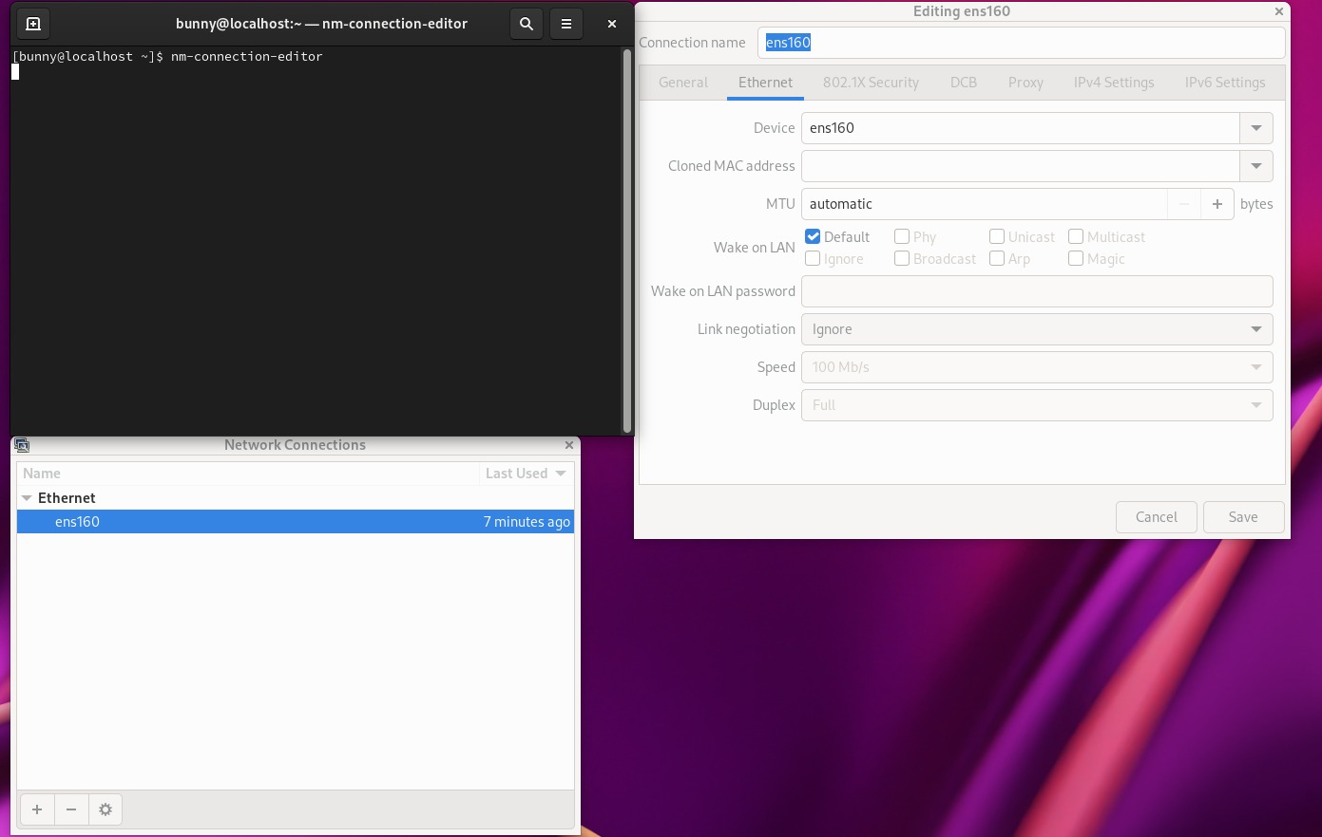

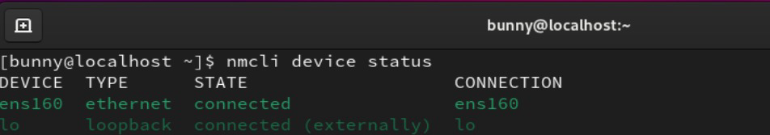
- Check current LAN connection

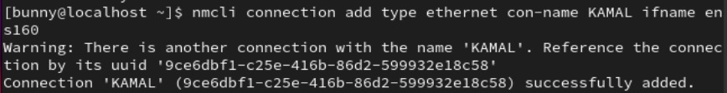
- Add new connection name “KAMAL”
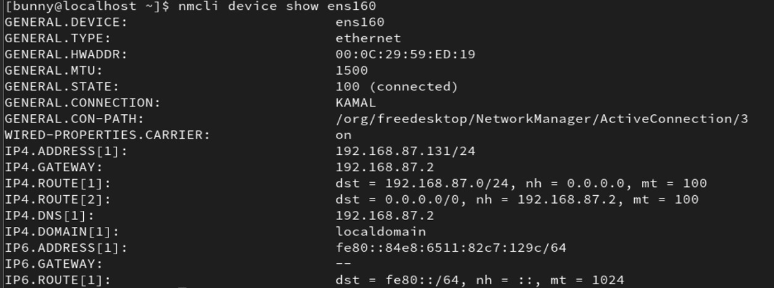

- Connect “ens160” to this new connection “KAMAL” and Up the new connection “KAMAL”, Show the info about the new connection.
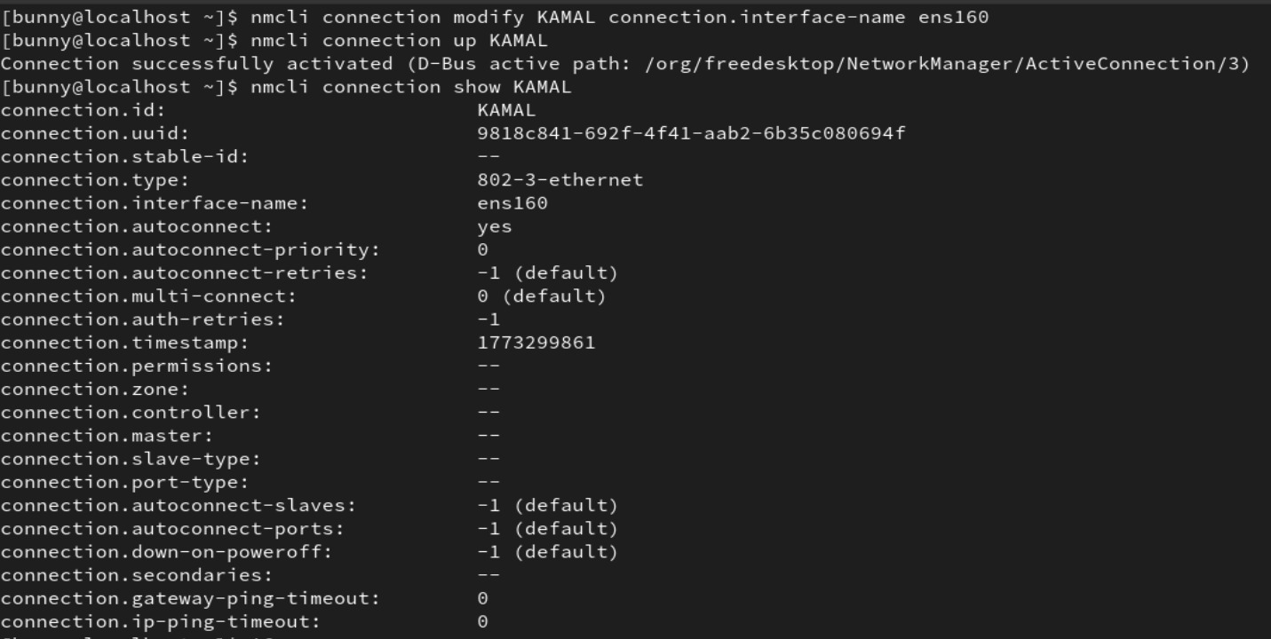

- Assign and append new IP on new connection “KAMAL” and Reload the connections.
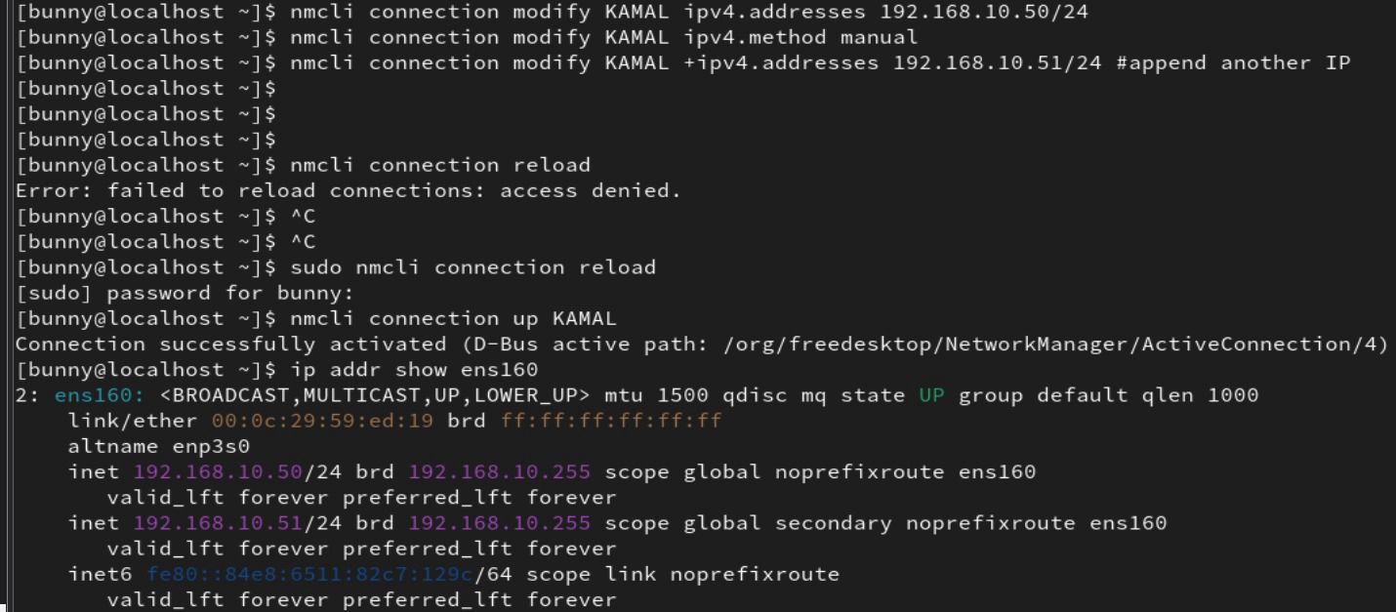

Task 2: Firewall

